Comp 2230 Assignment 1

*Stacks and things*

Finish a LinkedStack class and create a DropOut linked stack class with a test run case and UML diagram.

Ben Baxter T00032663

1/19/2015

Comp 2230 Assignment 1

Stacks and things

**Describe Problem**

We need to create methods for peek, size, isempty, and toString within the LinkedStack class. Peek needs to return the data from the node at the top of the stack without removing it. Size needs to return the size of the stack. isEmpty needs to tell whether the stack is empty or not. toString need to concatenate all the stacks data together and return it as a single string.

We also need to create another class called LinkedDropOutStack that when it reaches and arbitrary number n removes the bottom item on the stack to keep the stack at size n.

**Input**

* 5 Strings of length 4 each
* For Test Cases See Main thread in Code

**Output**

* Out for peek/toString/isEmpty/Size and demonstration of LinkedDropOutStack Pushover method.
* L1 is LinkedStack, L2 is LinkedDropOutStack

Linked Stack is size: 0

LinkedStack is Empty: true

Linked Stack Has: Yeeee43211234fdasasdf

Linked Stack is size: 5

LinkedStack is Empty: false

Linked drop out Stack is size: 0

Linked drop out Stack is Empty: true

Linked drop out Stack Has: Yeeee43211234fdasasdf

Linked drop out Stack is size: 5

Linked drop out Stack is Empty: false

L1 Peek:Yeeee

L2 Peek:Yeeee

Pushing over limit on L2

Linked drop out Stack is size: 5

Linked drop out Stack Has: asdfYeeee43211234fdas

Process finished with exit code 0

**UML’s and Analysis**

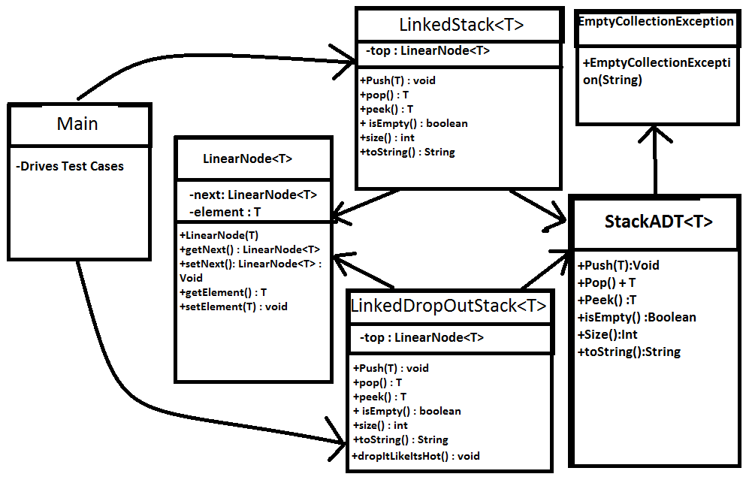

**Big O Analysis**

* Peek(1)
* Size(O)
* isEmpty(1)
* toString(O)
* dropItLikeItsHot(O)
* pop(1)
* push(1)

**Code**